**Super Smash TM4C**

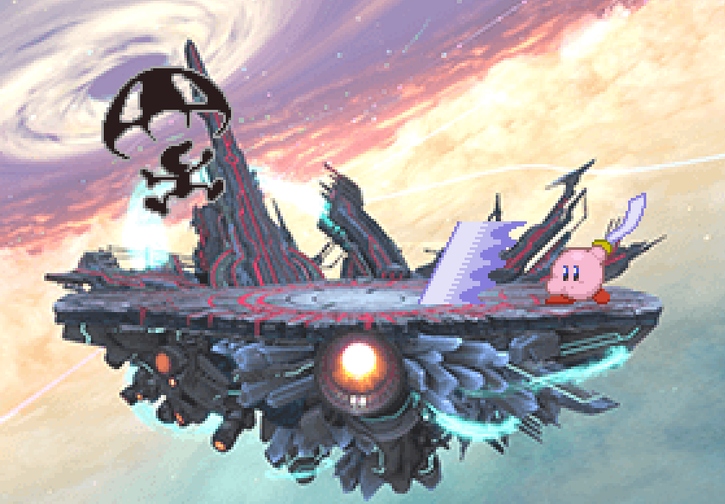

**Names:** Allen Jiang and Jason Math

**Overview:** 2-player platform fighting game featuring characters from various other games. Each character has its own unique moveset used to damage the other player, increasing the knockback of their attacks. To win, a player must knock the other player out of the screen three times.

**Features:**

·         Custom PCB of 2 separate controllers connected with a ribbon cable, each with its own:

o   TM4C

o   2-Axis Joystick

o   3 standard push buttons, 2 right-angle push buttons

o   LCD and SD card

·         SD card streaming 32K 8-bit music

·         Using the larger 320x240 ILI9341 display

·         3 Characters: Kirby, Game and Watch, and Valvano

·         Various stages including Final Destination and the UT Main Mall

·         Clipping! (oof)

·         Accurate circular and rectangular hitboxes/hurtboxes and collision detection

·         Master-Slave system between controllers

o   Master controller receives player inputs, runs the game, and sends sprite command packets to slave controller

o   Slave controller acts as GPU and outputs sprites onto both screens

**Requirements Met:**

·         At least 2 buttons and 1 ADC-sampled potentiometer

·         At least 3 sprites/images on screen

·         Sounds generated by DAC

·         Score displayed on each death

·         1 ISR for playing audio from buffer, 1 ISR for reading audio data into buffer from SD card

·         Languages: English and Spanish (changes audio narration)